Log eksekusi CI/CD yang berstatus sukses (Hijau)
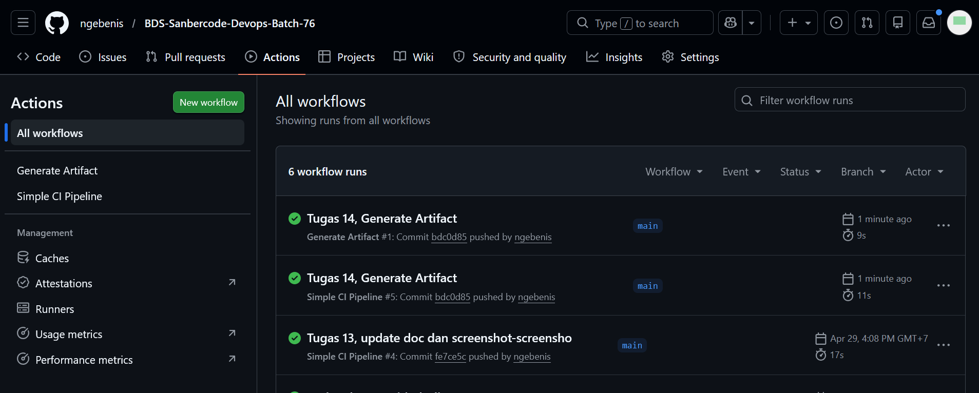
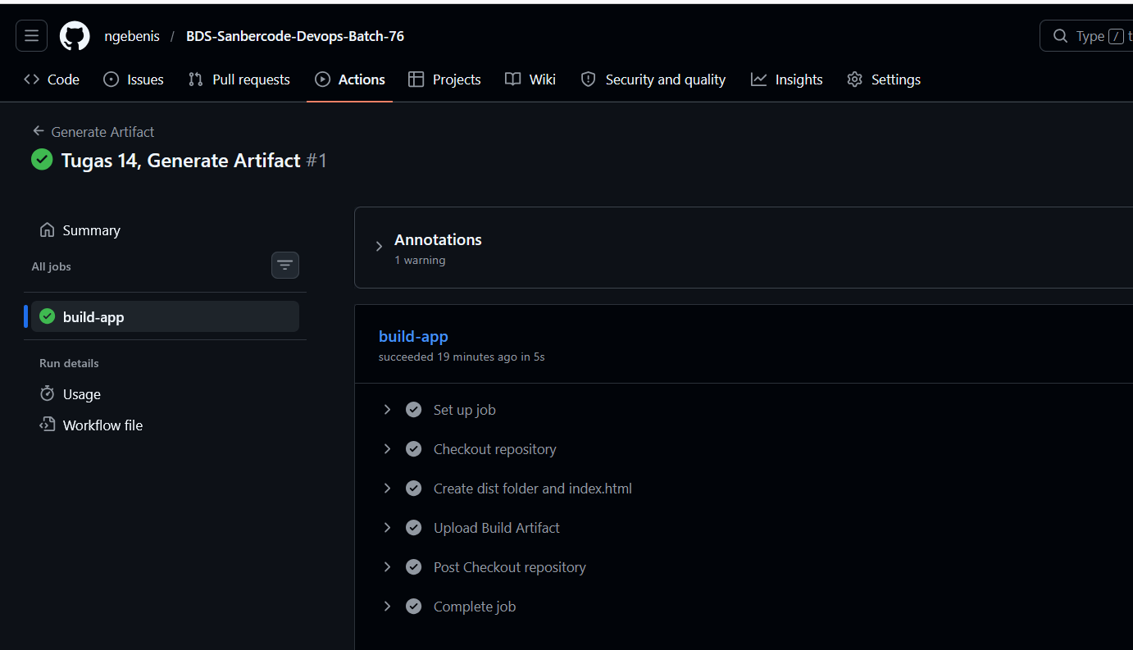
Buka build-app, di bagian Upload Build Artifact, Artifact download URL: https://github.com/ngebenis/BDS-Sanbercode-Devops-Batch-76/actions/runs/25157756653/artifacts/6726798278
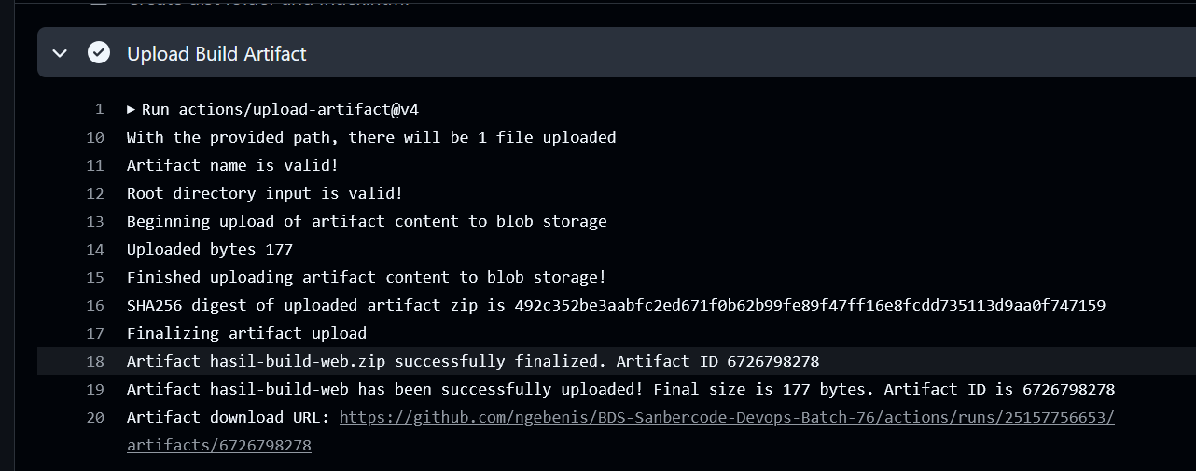

Klik link download file
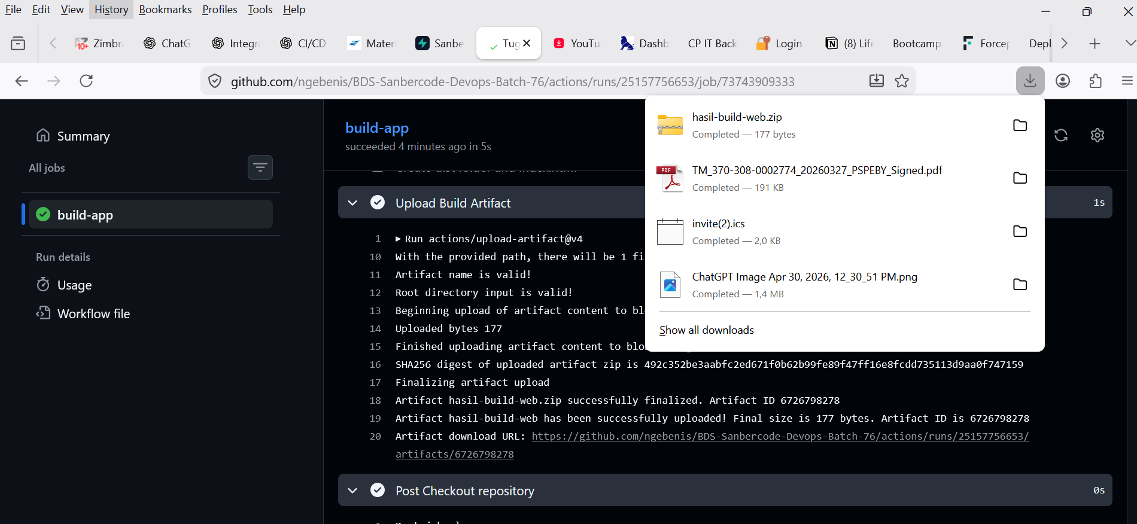
File hasil-build-web.zip terdownload.
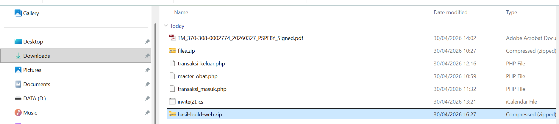

Extract hasil-build-web.zip
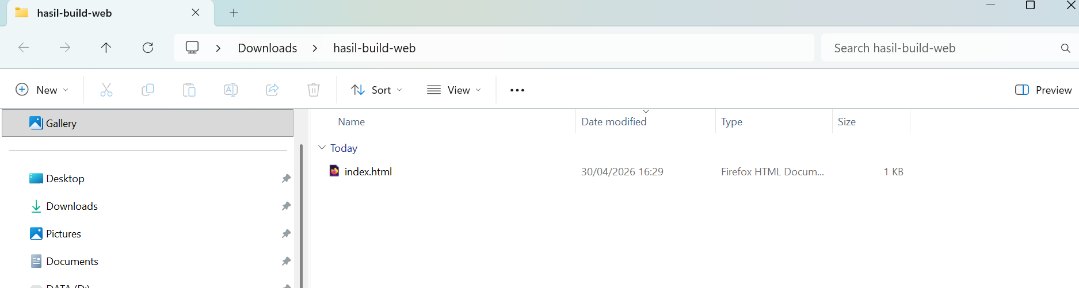

Open with browser.
